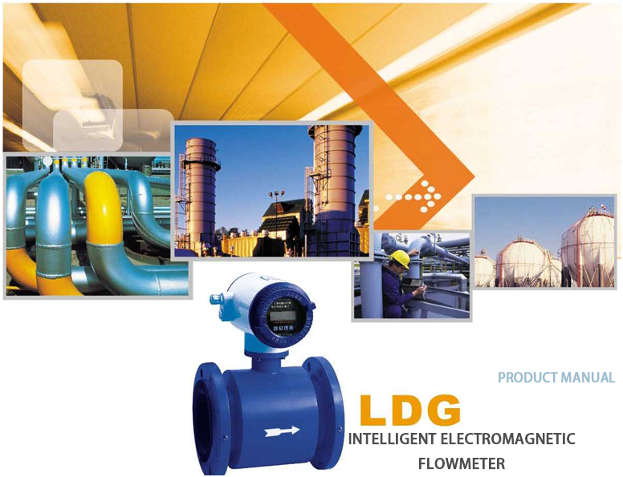
To measure the flow of positive and negative output pulse frequency output 4-20mA
Suporting RS-485 communication.

LDG type intelligent electromagnetic flowmeter

LDG intelligent electromagnetic flow meter for measuring the volume flow in closed conduits conductive liquid and slurry, such as clean water, sewage, various chemical salt solution, mud slurry . Pulp , pulp and liquid foods etc . Measuring principle
The measurement principle of the LDG type intelligent electromagnetic flowmeter is based on Faraday’s law of electromagnetic induction: when the conductive liquid cuts the magnetic force in the magnetic field, the conductor
generate induced electric potential . Its induced electric potential E is
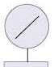

E=KBVD

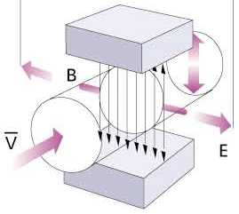
Measure the average flow velocity in the pipe section
Measure the inner diameter of the pipe section
Meter constant
where：k-
B-一 Magnetic induction
V-

When measuring the flow rate, the conductive liquid velocity ▽ flowing through the magnetic field perpendicular to the flow direction. Flowable electrically conductive liquid induces a velocity proportional to the average voltage. Which induced voltage signal by means of direct contact with the liquid of two or more detection electrodes. and sent through a cable converter through intelligent processing.
Then LCD display or convert into standard signal 4~ 20mA and 0~1 kHz output,

How to choose the right type
Selection instruments is very important work in the instrumentation applications. According to the data show , the instrument has practical applications in two-thirds of the failure is selected instrument error type and error safety equipment caused . Please pay special attention
1 . Data Collection
① Name of the measured fluid;
② Maximum flow, minimum flow:
③ Maximum working pressure,
④ Maximum temperature. Minimum temperature.
2. The measured fluid must have a certain degree of conductivity, with a conductivity of > 5nS / cm.
3. The maximum flow and minimum flow must comply with the values ​​in the table below：：
Inner diameter mm | 10 | 15 | 20 | 25 | 32 | 40 | 50 | 65
Minimum (m3/h) | 0.0283 | 0.0636 | 0J2 | 0.176 | 0.29 | 0.452 | 0.7 | 1.19
Maximum (m3/h) | /./ | 9.W | 16 96 | 26.5 | 43.42 | 67.85 | 106.0 | 179.0
Inner diameter mm | 80 | 100 | 125 | 150 | 200 | 250 | 300 | 350
Minimum (m3/h) | 1.8 | 2.82 | 4.41 | 6.36 | 11.3 | 17.6 | 25.4 | 34.6
Maximum (m³/h) | 271.0 | 424.0 | 662.0 | 954.0 | 1690 | 2650 | 3810 | 5190
Inner diameter mm | 400 | 450 | 500 | 550 | 600 | 700 | 800 | 900
Minimum (m3/h) | 45.2 | 57.2 | 77 6 | 85.5 | 101 0 | 138.0 | 180.0 | 2290
Maximum (m³/h) | 6780 | 8570 | 10600 | 12800 | 15200 | 2O7CO | 27100 | 34300
Inner diameter mm | 1000 | 1100 | 1200 | 1400 | 1600 | 1800 | 2000 | 2200
Minimum (mVh) | 282.0 | 342.0 | 407.0 | 554.1 | 732.7 | 9160 | 1131.0 | 1368,4
Maximum (m3/h) | 42400 | 51300 | 61000 | 83121 | 108566 | 137404 | 169635 | 205258

4． The actual maximum working pressure must be less than a meter rated working pressure.
5． The maximum operating temperature and minimum working temperature must meet the temperature requirements of the flowmeter.
6． To determine whether the presence of negative pressure.
You can select the table according to the respective traffic electromagnetic flowmeter, an inner diameter of the electromagnetic flowmeter if the selected match with the current process pipe inner diameter . Shall be shrink tube or pipe expansion,
1. If the pipeline shrink tube. Should be considered due to pressure loss, and reducers will affect the process.
2. Consider from the product price. You can choose a smaller caliber electromagnetic flowmeter. Relatively reduce investment.
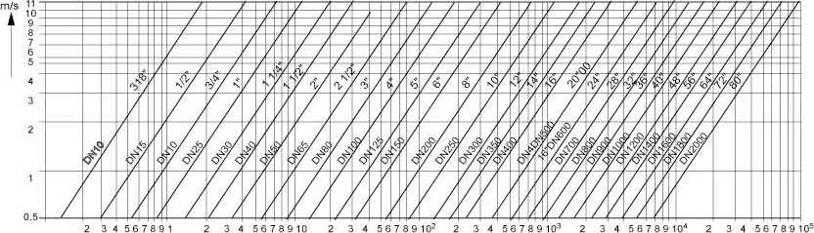
3. When measuring clean water. Economic velocity is 2-3m / s. When the measured solution and crystallization, should be appropriately increase the flow rate. Avoid dead electromagnetic flowmeter electrode is covered.
The relationship curve of flowmeter inner diameter, flow rate and quantity of flow .

•The relationship between the maximum distance of the split type, the cross-section of the copper core of the cable and the conductivity of the medium
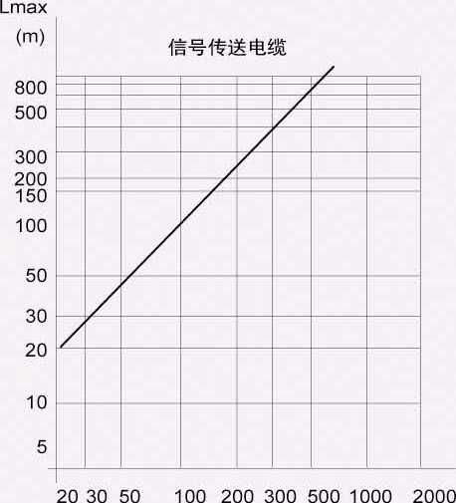
Signal transmission cable
For example: the conductivity of general tap water is about 100 p S/cm. The maximum distance of the split is about 100cm.
In practical applications, the shorter the separation distance, the better. The cable is too long. Affected by its distributed capacitance, it is easy to cause signal interference.
How to choose electrode material

The electrode material should be selected according to the corrosiveness of the fluid to be tested. Please refer to the relevant anti-corrosion manual. Tests should be made for special fluids.
Material | Corrosion resistance
Stainless steel containing molybdenum | Nitric acid. <5" C sulfuric acid at room temperature. Boiling phosphoric acid. Formic acid. Alkaline solution.
(0 Cr 18 Ni 12 Mo 2 Ti) | Sulfurous acid under certain pressure. Sea water, acetic acid
Hastelloy c Ha Ff will be gold B | Oxidizing acid resistance. Oxidizing salt. Sea water resistance. Non-oxidizing acid resistance. Non-oxygen
(HC, HB) | Chemical salt. Alkali. Sulfuric acid at room temperature
titanium | Sea water, various chlorides and hypochlorous hydrochloric acid. Chlorinated acids (including fuming nitric acid>,
(HC) | Organic acid, alkali
Tantalum | Other chemical media except hydrofluoric acid, fuming sulfuric acid and alkali. Including boiling point
(Ta) | Hydrochloric acid, nitric acid and <175' C sulfuric acid
platinum  (PD | Various acids, bases, and salts. Excluding aqua regia

How to choose lining material
The lining material should be selected according to the corrosiveness, abrasiveness and temperature of the measured medium

Lining  Name Symbol  material |  |  | Performance Maximum  working temperature |  | Applicable liquid
Rubber | Neoprene |  | Medium abrasion resistance. Resistant to the corrosion of low-concentration acid-base salts. | <80 *C | Tap water, industrial water, sea water
Rubber | Polyurethane rubber |  | Excellent wear resistance.  Poor acid and alkali resistance | <60 *C | Pulp, mineral pulp and other slurries
Fluoroplastic | Polytetrachloroethylene | F 4 or PTFE | The chemical performance is very stable. It is resistant to boiling hydrochloric acid .  Corrosion of sulfuric acid, aqua regia and concentrated alkali | <180 [ 'C | Corrosive acid-base salt liquid
Fluoroplastic | Translation of tetrafluoroethylene and hexafluoropropylene: Teflon FEP | F 46 or FEP | The chemical properties are slightly inferior to F 4 |  | Corrosive acid-base salt liquid
Fluoroplastic | Tetrafluoroethylene and ethylene | F 4 or ETFE | The chemical properties are slightly inferior to F 4 |  | Corrosive acid-base salt liquid
plastic | Polyethylene | P 0 | Stable chemical properties | <60 *C | Sewage
plastic | Polyphenylene sulfide | PPS |  | <150 *C | Hot water

How to choose the protection level
According to the national standard GB 4208-84 and the International Electrotechnical Commission standard IEC 529 76, the standards for the degree of protection of enclosures are:
IP 65: Water spray-proof type. Allows the tap to spray water to the sensor from any direction. The spray pressure is 30 kPa. The water output is 12.5 L / S and the distance is 3 m.
IP 68: Submersible type, long-term work in the water.
The degree of protection should be selected according to the actual situation. ■The sensor is installed below the ground, often flooded. P 68 should be used, and the sensor should be installed above the ground. IP 65 should be used.
How to choose additional features
The basic type of LDG intelligent electromagnetic flowmeter has display. Output 4_20 mA and 0_1 kHz. Alarm and other functions. Other additional functions can be added according to the actual situation:
1. Split installation: the sensor needs to be installed below the ground or other reasons. Split installation should be selected
2. RS - 485 communication: the sensor needs to communicate with other equipment. The RS - 485 communication function is required,
3. If you need other functions, please call to customize;
How to change the direction of the converter box
The converter box can be changed in four different directions as required.
1. Change of the direction of the converter box of the combined flowmeter
①Remove the 4 hexagon socket screws fixing the converter box ₌
②Turn the converter box to the ideal direction. Pay attention to the internal connection line when rotating.
③Re -fix the converter box.

How to choose the installation point correctly
The correct selection of the installation point and the correct installation of the meteor meter are both very important links. If there is a mistake in the installation process, the lighter will affect the accuracy of the star measurement. The heavy one will affect the service life of the flowmeter. It may even damage the flowmeter.
Pay special attention when choosing the installation location:
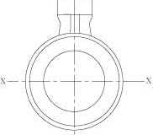
1. The axis of the measuring electrode must be approximately horizontal

2. The measuring pipe must be completely filled with liquid
3. Must be at least in front of the flowmeter 5xD {D is the inner diameter of the straight pipe meter) length. Backward must have at least 3xD (D is the flowmeter internal diameter) length of straight pipe

—「 —
5xD 3xD
4. The flow direction of the fluid is the same as the arrow direction of the flowmeter
5. A vacuum in the pipeline will damage the inner lining of the flowmeter. Special attention is required
6. There should be no strong electromagnetic field near the flowmeter
7. There should be ample space near the flowmeter for installation and maintenance.
8. If the measuring pipe vibration. Should be fixed in abutment on both sides of the flowmeter
9. Measurement of mixing liquids of different media. The distance between the mixing point and the
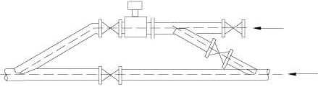
meter must have at least 30xD (D is the inner diameter of the meter) length meter must have at least 30xD (D is the inner diameter of the meter

10. In order to facilitate the cleaning and maintenance of the flowmeter in the future, a bypass pipeline should be installed.

11. When installing a PTFE-lined flowmeter . The bolts connecting the two flanges should be tightened evenly . Otherwise, the PTFE lining will be easily crushed . It is best to use a torque wrench.

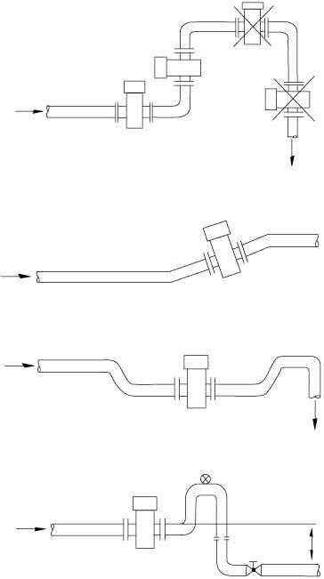
How to choose the correct installation method
It should be installed at the lower part of the horizontal pipe and the vertical upward position,
Avoid installation at the highest point of the pipeline and vertically downwards.

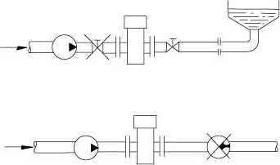

It should be installed on the rise of the pipeline.
Install in the pipe that discharges at the opening. should be installed at the lower part of the pipe

If the pipe drop exceeds 5m, install it downstream of the sensor.

The control valve and shut-off valve should be installed downstream of the sensor and installed at the outlet of the pump
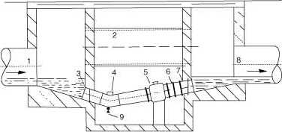
The sensor must not be installed at the inlet of the pump. It should be installed at the outlet of the pump

Measures of installing flow meters in measuring wells
1. inlet 2. Overflow pipe 3. Population gate
4. Cleaning hole 5. Flow meter 6. Short pipe
7. Outlet 8. Drain valve
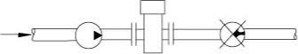

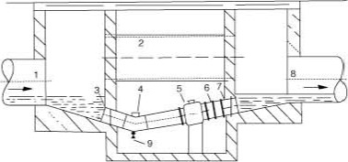

Instrument wiring and installation requirements

If the split installation is adopted, the connected signal cable adopts a customized special cable . The shorter the cable, the better

Excitation cable can choose YZ medium-sized rubber sheath cable . Its length is the same as that of signal cable.

The signal cable and the excitation cable must be strictly separated, cannot be laid in the same pipe, cannot be laid in parallel, and cannot be twisted together. They should be worn separately in the steel pipe.

Excitation signal cable and the cable as short as possible, excess cable volume can not be together . Shall be cut off excess cable . And re-weld joint.
The terminal label of the integrated converter
I +: | Flow current output
COM : | Current output ground
P +: | Two-way flow frequency (pulse ) output
COM : | Frequency (pulse ) output ground
AL : | Lower limit alarm output
AH ; | Upper limit report output
COM : | Report output destination
FUSE : | Input power fuse
T 1 +: | RS 485 communication output
T 2-: | RS 485 communication output
L 1: | 220 V (24 V ) power input
L 2: | The terminals of 220 V (24 V ) power input converter are marked:

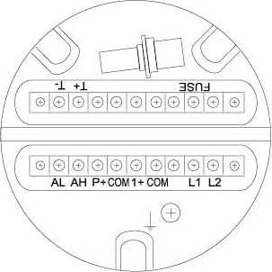

Terminal markings of split converters
SIGI： | Signal 1 | Connect to split type sensor
SGND: | Signal ground | Connect to split type sensor
SIG2： | Signal 2 | Connect to split type sensor
DSi: | Incentive shielding 1 | Connect to split type sensor
DS2： | Incentive shielding2 | Connect to split type sensor
EXT+： | Excitation current + | Connect to split type sensor
EXT-： | Excitation current - | Connect to split type sensor
INSW：
ICOUT： | Positive and negative flow current output
ICCOM： | Current output ground
ALM2： | Empty tube. Excitation disconnection status alarm output
PUL+； | Positive and negative flow frequency (pulse) output
PD old：
D- | Frequency (pulse) output ground | Two-way alarm output
COM： | Lower limit alarm output | Two-way alarm output
ALM I : | Upper limit alarm output | Two-way alarm output
STETR： | Alarm output ground | Two-way alarm output

Signal cable (double-core
Exciter（YHZ-2X1）
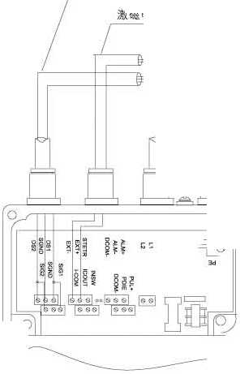
double-shielded STT3200)

Appearance of split electromagnetic flowmeter and converter installation ruler

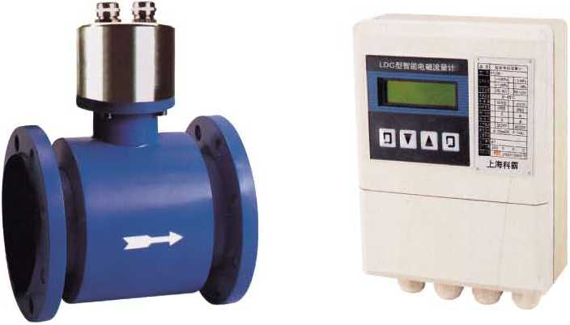

Converter appearance size
165x215x70 (width, height and thickness)
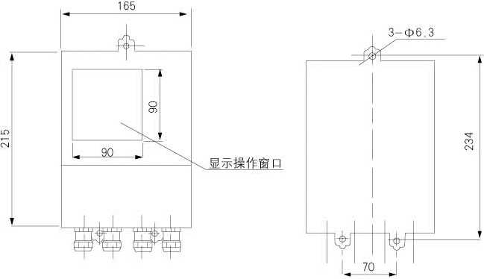
Show operation window
Converter installation size (wall-mounted)

The structure and dimensions of the plug-in electromagnetic flowmeter

DN | Standard pipe X wall thickness | R | L
250 | 273x11.5 | 125 | 600
300 | 325x12.5 | 150 | 625
350 | 377x3.5 | 175 | 650
400 | 426x3 | 200 | 675
450 | 480x15 | 90 | 565
500 | 530x15 | 100 | 575
600 | 630x9 | 120 | 595
700 | 720x10 | 140 | 615
800 | 820x10 | 160 | 635
900 | 920x10 | 180 | 655
1000 | 1020x10 | 200 | 675
1200 | 1220x10 | 240 | 715
1400 | 1420x10 | 280 | 755
1600 | 1620x10 | 320 | 795
1800 | 1820x10 | 360 | 835
2000 | 2020x10 | 400 | 975

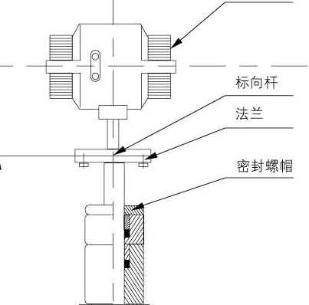
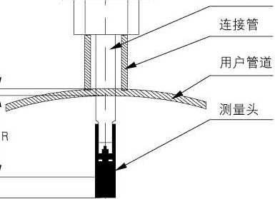
Structure composition: The plug-in electromagnetic flowmeter is composed of measuring head (electrode assembly 1. insertion rod, insertion mechanism (ball valve, connecting short pipe, flange, etc.) and converter (integrated or split) .

Pole

Flange

Sealing nut

Ball valve

Connecting pipe
User pipeline

Measuring head

Note: The relationship between the outer diameter and wall thickness of the standard pipe provided above is for reference only.
R is the insertion depth.

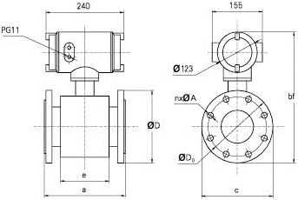
Overall dimensions of integrated flowmeter

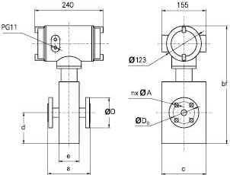
DN 6-20 DN 25-1000

DN | Rated pressure Apparatus dimensions (mm) |  |  |  |  |  | Flange connection size (mm)
DN | (MPa) a bf |  |  | c | d | e | D Do |  | nxA
10 | 4.0 | 150 | 408 | 156 | 107 | 72 | 90 | 60 | 4x14
15 | 4.0 | 150 | 408 | 156 | 107 | 72 | 95 | 65 | 4x14
20 | 4.0 | 150 | 408 | 156 | 107 | 72 | 105 | 75 | 4x14
25 | 4.0 | 150 | 303 | 115 |  | 78 | 115 | 85 | 4x14
32 | 4.0 | 150 | 319 | 140 |  | 78 | 140 | 100 | 4x18
40 | 4.0 | 150 | 332 | 150 |  | 93 | 150 | 110 | 4x18
50 | 4.0 | 200 | 346 | 165 |  | 109 | 165 | 125 | 4x18
65 | 4.0 | 200 | 367 | 185 |  | 105 | 185 | 145 | 8x18
80 | 4.0 | 200 | 382 | 200 |  | 101 | 200 | 160 | 8x18
100 | 1 .6 | 250 | 397 | 220 |  | 150 | 220 | 180 | 8x18
125 | 1 .6 | 250 | 429 | 250 |  | 150 | 250 | 210 | 8x18
150 | 1 .6 | 300 | 459 | 285 |  | 180 | 285 | 240 | 8x22
200 | 1.0 | 350 | 517 | 340 |  | 222 | 340 | 295 | 8x22
250 | 1.0 | 400 | 570 | 395 |  | 254 | 395 | 350 | 12x22
300 | 1.0 | 500 | 617 | 445 |  | 316 | 445 | 400 | 12x22
350 | 1.0 | 500 | 668 | 505 |  | 305 | 505 | 460 | 16x22
400 | 1.0 | 600 | 723 | 565 |  | 380 | 565 | 515 | 16x26
450 | 1.0 | 600 | 773 | 615 |  | 380 | 615 | 565 | 20x26
500 | 1.0 | 600 | 825 | 670 |  | 400 | 670 | 620 | 20x26
600 | 1.0 | 600 | 930 | 780 |  | 456 | 780 | 725 | 20x30
700 | 1.0 | 700 | 1038 | 895 |  | 545 | 895 | 840 | 24x30
800 | 1.0 | 800 | 1148 | 1015 |  | 580 | 1015 | 950 | 24x33
900 | 1.0 | 900 | 1248 | 1115 |  | 690 | 1115 | 1050 | 28x33
1000 | 1.0 | 1000 | 1355 | 1230 |  | 750 | 1230 | 1160 | 28x36
1200 | 0.6 | 1200 | 1674 | 1405 |  | 1206 | 1405 | 1340 | 32x33
1400 | 0.6 | 1400 | 1874 | 1630 |  | 1406 | 1630 | 1560 | 36x36
1600 | 0.6 | 1600 | 2084 | 1830 |  | 1606 | 1830 | 1760 | 40x36
1800 | 0.6 | 1800 | 2304 | 2045 |  | 1806 | 2045 | 1970 | 44x39
2000 | 0.6 | 2000 | 2504 | 2265 |  | 2006 | 2265 | 2180 | 48x42
2200 | 0.25 | 2200 | 2704 | 2405 |  | 2206 | 2405 | 2315 | 52x45

Flowmeter model description
Specification code Description
Instrument type | LDG |  |  |  |  |  |  |  |  | Intelligent electromagnetic flowmeter
Path code | XXX |  |  |  |  |  |  |  | Example 100 means DNIOO. If the path is followed by 丨, it means plug-in.  Connect AI means adjustable plug-in
Electrode form | 1 |  |  |  |  |  |  |  | Standard fixed
Electrode form | 2 |  |  |  |  |  |  |  | Scraper
Electrode form | 3 |  |  |  |  |  |  |  | Removable and replaceable
Electrode Materials |  | 0 |  |  |  |  |  |  | stainless steel
 |  | 1 |  |  |  |  |  |  | Platinum Pt
 |  | 2 |  |  |  |  |  |  | HastelloyB(HB}
 |  | 3 |  |  |  |  |  |  | TantalumTa
 |  | 4 |  |  |  |  |  |  | TitaniumT_
 |  | 5 |  |  |  |  |  |  | HastelloyC(HC>
Lining material |  |  | 3 |  |  |  |  |  | Neoprene
 |  |  | 4 |  |  |  |  |  | Polyurethane rubber
 |  |  | 5 |  |  |  |  |  | F4(PTEE)polytetrafluoroethylene
 |  |  | 6 |  |  |  |  |  | F46(FEP)Polyfluoroethylene propylene
 |  |  | 7 |  |  |  |  |  | F40(ETFE)tetrafluoroethylene-ethylene copolymer
 |  |  | 8 |  |  |  |  |  | P〇(PE)polyethylene
 |  |  | 9 |  |  |  |  |  | PPSpolyphenylene sulfide
Rated pressure(MPa> |  |  | 4.0 |  |  |  |  |  | DN10.80
 |  |  | 1.6 |  |  |  |  |  | DN100-150
 |  |  | 1.0 |  |  |  |  |  | DN200-1000
 |  |  | 0.6 |  |  |  |  |  | DN1100-2000
 |  |  | 0.25 |  |  |  |  |  | DN2200
Working temperature |  |  |  | E |  |  |  |  | <8(TC
 |  |  |  | H |  |  |  |  | <180‘C
Grounding ring |  |  |  | 0 |  |  |  |  | Without grounding ring
 |  |  |  | 1 |  |  |  |  | With grounding ring
Protection leve |  |  |  |  | 0 |  |  |  | IP65
 |  |  |  |  | 1 |  |  |  | IP68
Converter type |  |  |  |  | 0 |  |  |  | All-in-one
 |  |  |  |  | 1 |  |  |  | Split
Communication |  |  |  |  |  | 0 |  |  | No
 |  |  |  |  |  | 1 |  |  | RS-485
 |  |  |  |  |  | 2 |  |  | Hart
 |  |  |  |  |  | 3 |  |  | PA bus
 |  |  |  |  |  | 4 |  |  | FFbus
Shell material |  |  |  |  |  |  | -0 |  | Carbon steel
 |  |  |  |  |  |  | 1 |  | stainless steel
Meter body flange |  |  |  |  |  |  | 0 |  | Carbon steel
 |  |  |  |  |  |  | 1 |  | stainless steel
Install timing flange |  |  |  |  |  |  |  | 0 | Imperial
 |  |  |  |  |  |  |  |  | band
Power supply |  |  |  |  |  |  |  | 0 | 220VAC
 |  |  |  |  |  |  |  | 1 | 24VDC
Meter mileage （XXX) |  |  |  |  |  |  |  |  | Example: (2000) means that the maximum current corresponding to 20mA is 2000m3/h

Example丨: LDG—100-223-1.6E-0000-0010

Description 1: LDG type intelligent electromagnetic flow chamber meter. DN100. Scraper type Hastelloy B electrode. Neoprene lining. Rated pressure 1.6Mpa. Temperature <8 (TC. No grounding ring. IP65.-Integrated. No communication. Shell Materials and the body flange is carbon steel. With mounting matching flange (including bolts and nuts). 220V AC power supply,

Example 2: LDG-5001 _ 105-1.6E-0000-1001 (2000)

Description 2.1_06 plug-in intelligent electromagnetic flow meter, 01^00. Standard fixed stainless steel electrode. Plastic lining rated pressure 1.6(^^. Temperature<80;(:. No grounding ring. 1? 65.-Asana. No communication. The outer shell material is stainless steel. The flange of the meter body is carbon steel. There is no mounting matching flange. 24V DC power supply. The maximum current setting corresponding to 20nA is 20X>nVh.
Technical Parameters
The performance value of the product does not exceed the error given. The error-free value given refers to the Average performance value obtained from a series of instruments of the same model.
Measuring fluid -- 一conductive liquid, slurry
Conductivity >5 p S/cm
Velocity range 0.5~10m/s
Extended range 0.1~15m/s
Flow direction - -一Positive. Reverse, flow
Accuracy level一 一 ±0.2% ±0.3% ±0.5%
Repeatability ±0.1% ±0.15% ±0.25%
Work pressure < 4 .Ompa (DN10-80)
<1,6mpa(DN!00~150)
<1. Ompa (DN200-1000) <0.6mpa(DN1100-2200) Special pressure-resistant customized fluid temperature一 一E Level<80々
—H Level <180'C
Protection level IP65
IP68
Electrode material一 -- stainless steel 316L

Hastelloy (B.C) Bags
—Titanium electrode form- 一Standard, scraper. Foldable
Number of electrodes 2- 6
Lining material Neoprene
Polychloroprene rubber
-F4IPTFE) PTFE
F46(FEP) PTFE
F40(ETFE) PTFE
PO(PE) Polyethylene
--PPS benzene sulfide flange material Carbon steel. Stainless steel
output signal Standard current 4〜20mA
-Frequency 0~1kHz output function -- 一Forward and reverse, net flow signal
Communication RS-485
Hart
PA master-FF bus alarm (normally open) one-empty pipe
.Excitation, flow upper and lower limits
Power supply DC24V10VA
AC220V10VA working environment一- -- Temperature：-25'C~60'C
—Humidity：5%~90%

